Ceph installation on windows

Step -1 ########### ########## Install Dokan library #######################
In order to mount Ceph filesystems, ceph-dokan requires Dokany to be installed. You may fetch the installer as well as the source code from the Dokany GitHub repository:
https://github.com/dokan-dev/dokany/releases
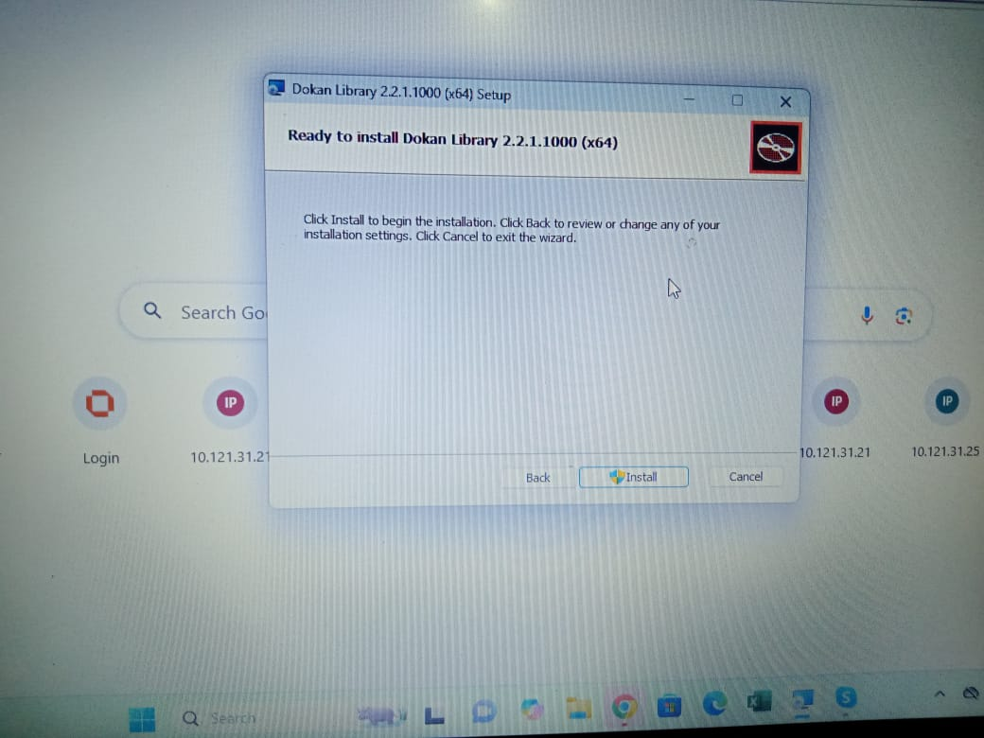
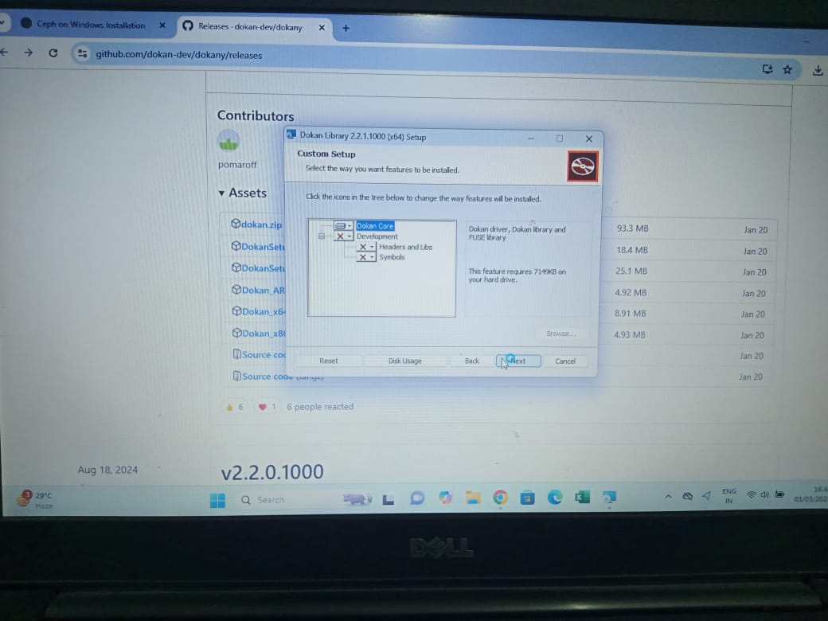
After installation please restart the system.
Step -2 #########install msi installer##############################

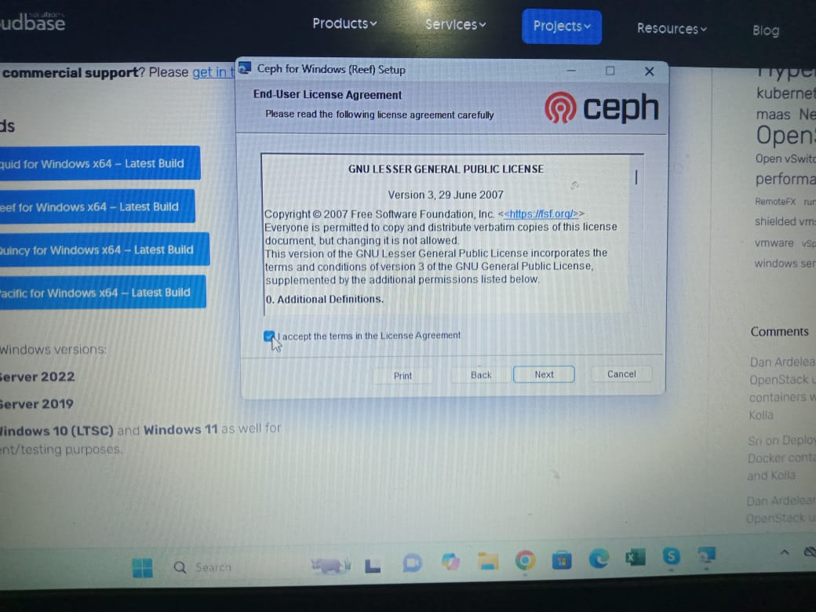
Using the MSI installer is the recommended way of installing Ceph on Windows. It can be downloaded from here: https://cloudbase.it/ceph-for-windows
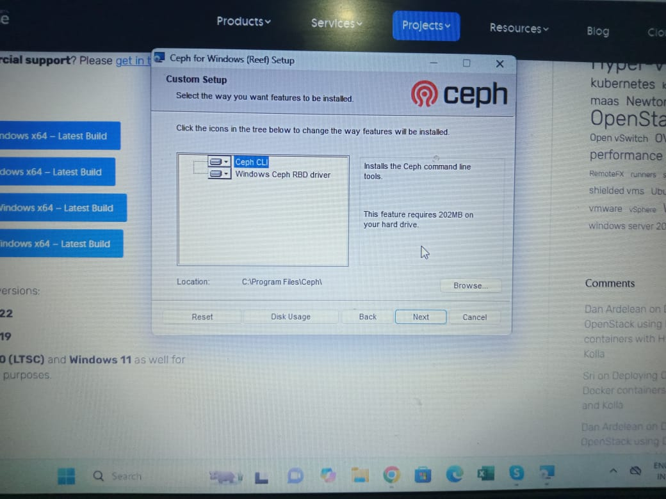
A server reboot is required after uninstalling the driver, otherwise subsequent install attempts may fail.

Step -3 ################ Create the Directory C:/ProgramData/ceph
These directory and files are all created on powershell open in Administration.

Add the keys in this directory
-- ceph.client.admin.keyring
-- ceph.client.Administrator.keyring
-- ceph.client.DELL.keyring
-- ceph.conf
##In ceph.conf

[global]
log to stderr = true
; Uncomment the following in order to use the Windows Event Log
; log to syslog = true

run dir = C:/ProgramData/ceph/out
crash dir = C:/ProgramData/ceph/out

; Use the following to change the cephfs client log level
; debug client = 2
mon host = 10.121.223.21
[client]
keyring = C:/ProgramData/ceph/ceph.client.admin.keyring
; log file = C:/ProgramData/ceph/out/$name.$pid.log
admin socket = C:/ProgramData/ceph/out/$name.$pid.asok

; client_permissions = true
; client_mount_uid = 1000
; client_mount_gid = 1000

Step-4 ##############Mounting filesystems#########################
In order to mount a ceph filesystem, the following command can be used:
ceph-dokan.exe -c c:\ProgramData\ceph\ceph.conf -l <x>
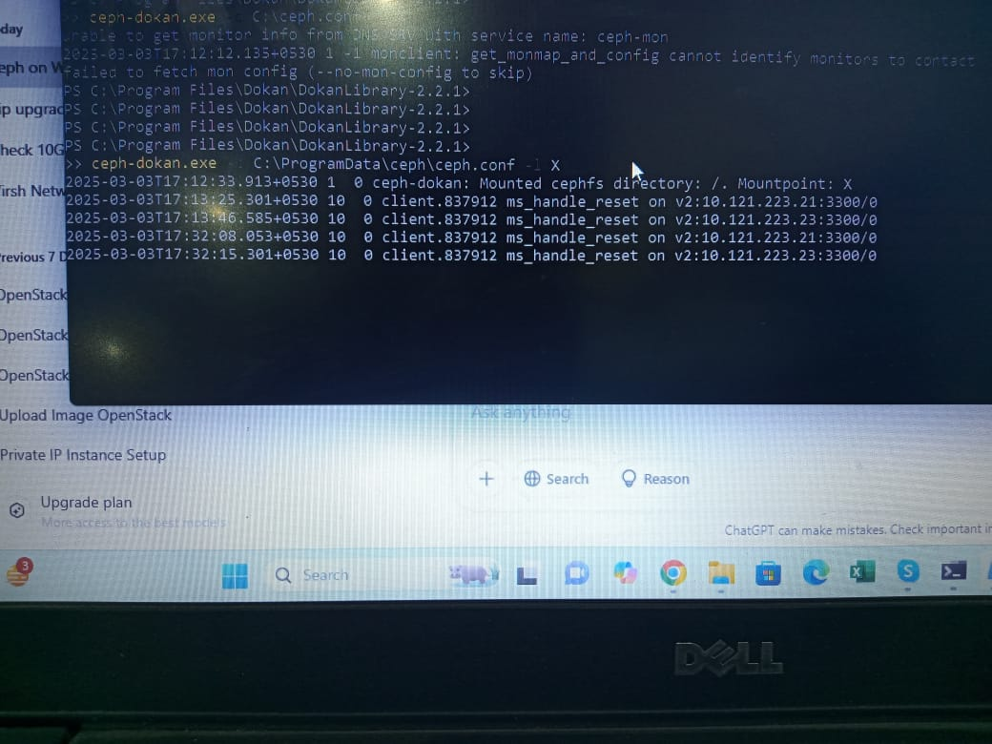

Step-5 Here we can see the mounted filesystem as a disk.
